CURRICULUM VITAE

Andreas Kaltzoglou

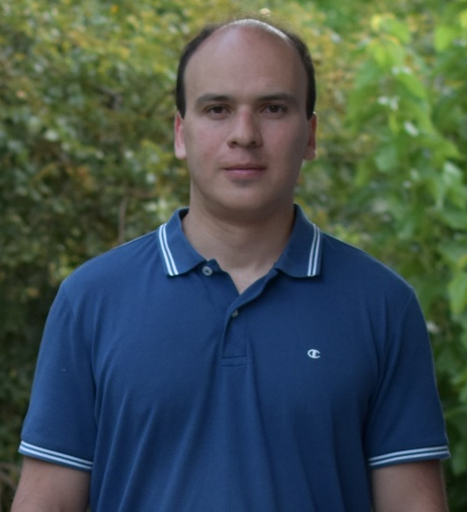
Associate Researcher
Theoretical and Physical Chemistry Institute
National Hellenic Research Foundation
48 Vassileos Constantinou Ave.
Athens 11635, Greece

Tel: +30 210 7273845
E-mail: akaltzoglou@eie.gr

EDUCATION

- Ph.D. in Chemistry, Technical University of Munich, Germany (2009)
- M.Sc. in Chemistry, Aristotle University of Thessaloniki, Greece (2005)
- B.Sc. in Chemistry, Aristotle University of Thessaloniki, Greece (2003)

PROFESSIONAL EXPERIENCE AND APPOINTMENTS

07/2020 – present: Associate Researcher, Theoretical and Physical Chemistry Institute, National Hellenic Research Foundation, Greece
11/2014-06/2020: Postdoctoral Research Associate in Chemistry, National Center for Scientific Research "Demokritos", Greece
02/2017-06/2020: Teaching Fellow, Materials Science Department, University of Patras, Greece
09/2013-06/2014: Postdoctoral Research Associate in Chemistry, University of Reading, United Kingdom
09/2012-08/2013: Postdoctoral Research Associate in Chemistry, Heriot-Watt University, Edinburgh, United Kingdom
12/2011-06/2012: Fixed-term Lecturer in Inorganic and Physical Chemistry, Heriot-Watt University, Edinburgh, United Kingdom
09/2010-11/2011: Postdoctoral Research Associate in Chemistry, Heriot-Watt University, Edinburgh, United Kingdom

MAIN RESEARCH INTERESTS

- Exploratory Synthesis in Solution and Solid State of Inorganic and Organic-Inorganic Compounds
- X-ray and neutron diffraction for structural analysis
- Spectroscopic analysis (UV-Vis, NMR, IR, Raman)
- Solar cell materials
- Thermoelectric materials
- Luminescent materials

TEACHING EXPERIENCE

- Teaching Fellow in Crystallography and Semiconductors, Materials Science Department, University of Patras, Greece, 02/2017-06/2020.
- Supervision of a Doctoral Thesis, National Center for Scientific Research "Demokritos", Greece, since 11/2016.
- Supervision of a Bachelor Thesis, Materials Science Department, University of Patras, Greece, 11/2018-6/2019.
- Fixed-term Lecturer in Inorganic and Physical Chemistry, Heriot-Watt University, Edinburgh, United Kingdom, 12/2011-06/2012.
- Laboratory supervision of Undergraduate Chemical Analysis Courses at the Chemistry Department, Technical University of Munich, Germany, 01/2006-04/2009.

PROFESSIONAL AFFILIATIONS & ACTIVITIES

- Member of the Greek Chemists Association.
- Member of the Hellenic Society for the Science and Technology of Condensed Matter.
- Reviewer for scientific research journals in the fields of inorganic chemistry, physical chemistry and materials for energy-conversion applications.

AWARDS AND DISTINCTIONS

- Principal investigator for the Research Project ‘Advanced Materials for Perovskite Solar Cells’ (since 4/2021) (Hellenic Foundation for Research & Innovation)
- EU Marie-Curie Scholarship for Doctoral Studies (FP5-ITN) at the Technical University of Munich, Germany
- Scholarship of Excellence by the Greek Scholarship Foundation in 2003 as Postgraduate Student.
- Scholarship of Excellence by the Greek Scholarship Foundation in 1999 as Undergraduate Student.

SELECTED PUBLICATIONS

- “Copper(I) bromide complexes from 1,2-bis(diphenylphosphano)benzene and some heterocyclic thiones”, A. Kaltzoglou, P. Cox, and P. Aslanidis, Inorganica Chimica Acta 358, 3048 (2005).
- “Order-disorder phase transition in type-I clathrate Cs₈Sn₄₄”, A. Kaltzoglou, S. Hoffmann, and T. Fässler, European Journal of Inorganic Chemistry 4162 (2007).
- “Halogen effects on ordering and bonding of CH₃NH₃⁺ in CH₃NH₃PbX₃ (X = Cl, Br, I) hybrid perovskites: A vibrational spectroscopic study”, R. G. Niemann, A. G. Kontos, D. Palles, E. I. Kamitsos, A. Kaltzoglou, F. Brivio, P. Falaras, and P. J. Cameron, Journal of Physical Chemistry C 120, 2509 (2016).
- “Optical-vibrational properties of the Cs₂SnX₆ (X = Cl, Br, I) defect perovskites and hole-transport efficiency in dye-sensitized solar cells”, A. Kaltzoglou, M. Antoniadou, A. G. Kontos, C. C. Stoumpos, D. Perganti, E. Siranidi, V. Raptis, K. Trohidou, V. Psycharis, M. G. Kanatzidis, and P. Falaras, Journal of Physical Chemistry C 120, 11777 (2016).
- “Reentrant structural and optical properties and large positive thermal expansion in perovskite formamidinium lead iodide”, D. H. Fabini, C. C. Stoumpos, G. Laurita, A. Kaltzoglou, A. G. Kontos, P. Falaras, M. G. Kanatzidis, and R. Seshadri, Angewandte Chemie International Edition 55, 15392 (2016).
- “Trimethylsulfonium lead triiodide: an air-stable hybrid halide perovskite”, A. Kaltzoglou, C. C. Stoumpos, A. G. Kontos, G. K. Manolis, K. Papadopoulos, K. G. Papadokostaki, V. Psycharis, C. C. Tang, Y.-K. Jung, A. Walsh, M. G. Kanatzidis, and P. Falaras, Inorganic Chemistry 56, 6302 (2017).

